Name: ___________________________________________________________ Date: _____________

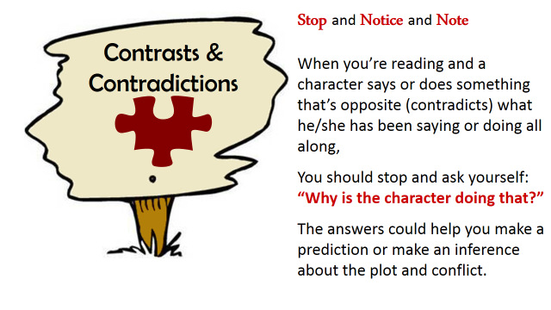

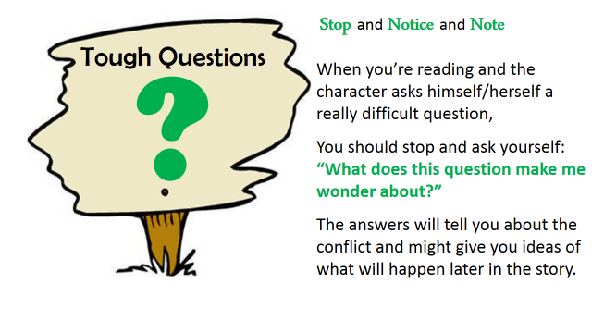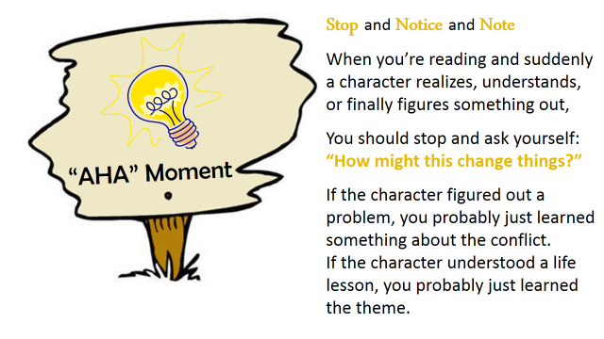

Name: ___________________________________________________________ Date: _____________

